SQL PROJCET SYNTAX

ALTER TABLE data1

ADD COLUMN SalesPrice as (Orderqty * unitprice);

ALTER TABLE data1

ADD COLUMN CostPrice as (Orderqty * unitcost);

ALTER TABLE data1

ADD COLUMN Profit as (SalesPrice - CostPrice);

CREATE TABLE NewTable as

SELECT

OrderNumber,

SalesChannel,

Salesteamindex,

Orderqty,

unitprice,

unitcost,

SalesPrice,

CostPrice,

Profit,

data2.SalesTeam,

data2.Region,

data3.ProductCategory,

data3.ProductName,

data4.state

FROM

data1

INNER JOIN

data2 on data1.Salesteamindex = data2.Id_Index

INNER JOIN

data3 on data1.Salesteamindex = data3.Index_Id

INNER JOIN

data4 on data1.Salesteamindex = data4.id;

1. SELECT sum(SalesPrice) as TotalSalesRevenue

FROM NewTable

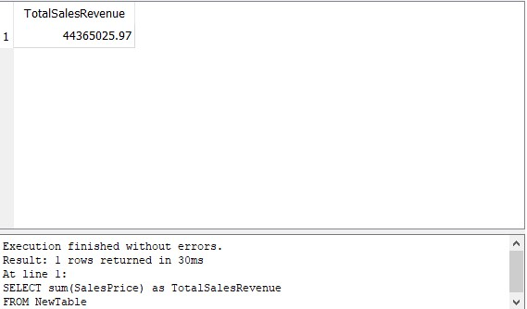

1. SELECT ProductName, Orderqty, OrderNumber, SalesChannel

FROM NewTable

GROUP by ProductName

HAVING SalesChannel in ("In-Store", "Distributor");

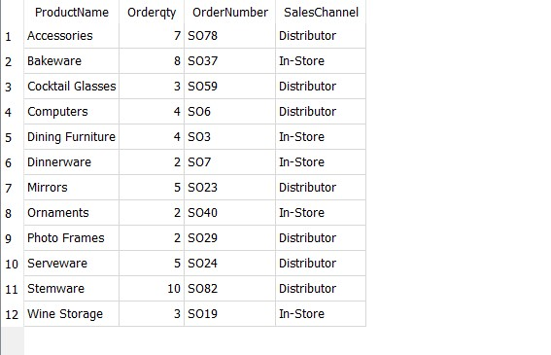

1. SELECT ProductName, sum(Orderqty), sum(SalesPrice), SalesTeam

FROM NewTable

GROUP by ProductName

HAVING SalesTeam in ("Nicholas Cunningham");

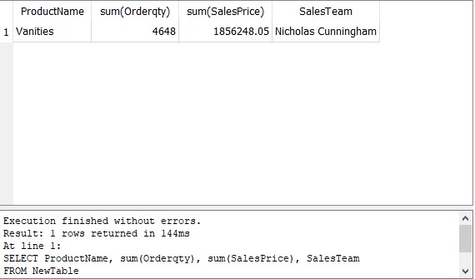

1. /*SELECT avg(Orderqty) as average

FROM NewTable*/

SELECT *

FROM NewTable

WHERE Orderqty > 5.5201;

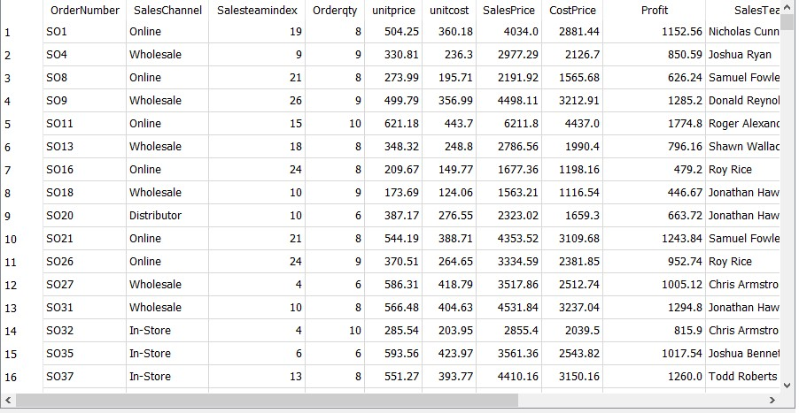

1. SELECT ProductName, sum(Orderqty) as QuantitiesOrdered

FROM NewTable

GROUP by ProductName

ORDER by QuantitiesOrdered DESC

LIMIT 10 OFFSET 0;

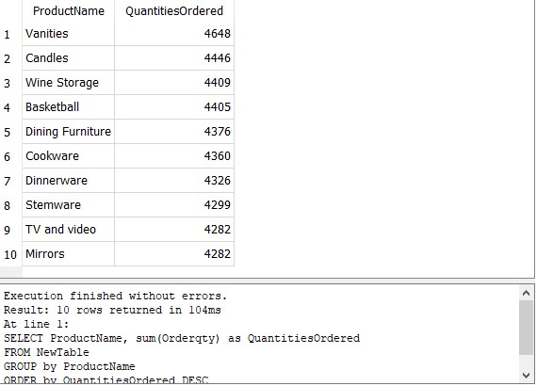

1. SELECT state, sum(Orderqty) as OrderSold

FROM NewTable

GROUP by state

HAVING state in ("Alabama");

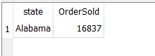

1. SELECT *

FROM NewTable

WHERE OrderNumber = "SO471";

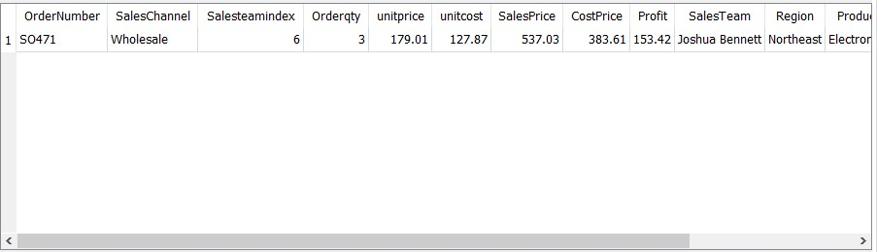

1. SELECT Region, avg(Profit) as AverageProfit

FROM NewTable

GROUP by Region

ORDER by AverageProfit DESC;

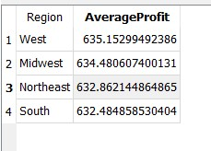

1. SELECT ProductCategory, count(OrderNumber) as OrderCounts

FROM NewTable

GROUP by ProductCategory

HAVING OrderCounts >= 2000;

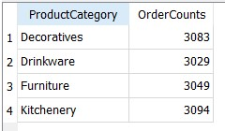

1. SELECT ProductName, sum(Orderqty) as TotalQuantities

FROM NewTable

GROUP by ProductName

ORDER by TotalQuantities DESC

LIMIT 5 OFFSET 0;

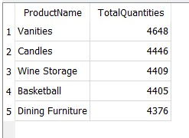

SELECT ProductName, sum(Orderqty) as TotalQuantities

FROM NewTable

GROUP by ProductName

ORDER by TotalQuantities ASC

LIMIT 5 OFFSET 0;

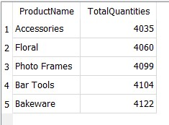

SELECT ProductName as ExpensiveProducts, sum(Orderqty) as TotalQuantities, unitprice

FROM NewTable

GROUP by ProductName

ORDER by unitprice DESC

LIMIT 5 OFFSET 0;

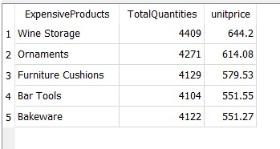

SELECT ProductName as CheapProducts, sum(Orderqty) as TotalQuantities, unitprice

FROM NewTable

GROUP by ProductName

ORDER by TotalQuantities ASC

LIMIT 5 OFFSET 0;

